# Crowe Pandemic Response

The Crowe Pandemic Response App-Pack aggregates external data, including government mandates, closures, virus cases and more, and correlates it with an organization’s internal data, such as employees, vendors, customers, products, and facilities. This tool centralizes the data executives need to identify emerging risks, adapt business initiatives and, most importantly, care for their employees.

On this page

* Release history
* Overview of Pandemic Response
  + Key features and benefits
  + Prerequisites (ODA and system requirements)
  + Compatible Use Cases and Applications
    - Related Applications
  + Additional resources
* Crowe Pandemic Response components
  + Architecture diagram
  + Swim Lane diagrams
    - Pandemic self-assessment
    - Pandemic cases
    - Exposure actions
    - Support actions
    - Essential personnel authorization
  + Applications
  + Personas and Access Roles
* Configure core applications
  + Task 1: Add fields to the contacts application
  + Task 2: Adjust the calculation order in the contacts application
  + Task 3: Set a daily calculation schedule in the contacts application
  + Task 4: Add fields to the layout in the contacts application
  + Task 5: Setup bulk action schedule
  + Task 6: Add fields to the facilities application
  + Task 7: Add fields to the layout in the facilities application
* Installing Pandemic Response
  + Installation overview
    - Step 1: Prepare for the installation
    - Step 2: Install the package
    - Step 3: Set up data feeds
    - Step 4: Test the installation
  + Installing the package
    - Task 1: Back up your database
    - Task 2: Import the package
    - Task 3: Map objects in the package
    - Task 4: Install the package
    - Task 5: Review the package installation log
    - Task 6: Activate workflow
    - Task 7: Setting up schedules
    - Task 8: Setting up data feeds
    - Import a data feed
    - Task 9. Modifying the general user access role
    - Task 10: Validating dashboards
* Using Pandemic Response
  + Task 1: Navigation
  + Archer user accounts
    - Task 1: Adding/Managing user accounts
  + Facilities and contacts
    - Task 1: Adding a new facilities record
    - Task 2: Adding a new contact record
  + Jurisdictions, responses and mandates
    - Task 1: Review jurisdictions and mandates
    - Task 2: Create a new jurisdiction
    - Task 3: Create a new mandate record
  + Pandemic cases
    - Task 1: Create and submit a pandemic case
    - Task 2: Perform initial review of a pandemic case
    - Task 3: Submit completion of pandemic case actions
    - Task 4: Perform final review of a pandemic case
  + Pandemic self-assessments
    - Task 1: Creating and submitting a pandemic self-assessment
    - Task 2: Review a pandemic self-assessment
    - Task 3: Scheduling pandemic self-assessments
  + Support actions
    - Task 1: Create and submit a support action
    - Task 2: Review a support action
    - Task 3: Complete delivery
    - Task 4: Complete recovery
  + Exposure actions
    - Task 1: Create and submit an exposure action
    - Task 2: Review an exposure action
  + Essential personnel authorization
    - Task 1: Create and submit an essential personnel authorization
    - Task 2: Perform primary review of essential personnel authorization
    - Task 3: Perform secondary review of essential personnel authorization
* Appendix A
* Appendix B

## Release history

Last updated: May 2020

## Overview of Pandemic Response

### Key features and benefits

* Centralize your data, decisions, and actions in one place - The data is out there, but it takes too much time to gather and make sense of it within the context of your business. Crowe Pandemic Response solves that by aggregating external data about government mandates, closures, virus cases, and more, and correlates it with internal data about employees, vendors, customers, products, and facilities.
* Gain visibility with centralized, correlated data - Replace your disparate data sources and spreadsheets with one tool that gathers and correlates the data you need to identify emerging risks, adapt the business, and, most importantly, care for employees.
* Improve efficiency - Spend less time figuring out how to manage your response. With data in one place, you can make faster, better decisions about how you interact with your employees, clients, vendors, customers, healthcare organizations, and governmental agencies.
* Prioritize actions - With correlation of external and internal data, you can understand emerging risks and triage high priority concerns related to employee health, workforce management, and other operational issues.
* Coordinate responses - Get everyone on the same page quickly and establish consistency when it comes to communication, support actions, exposure management, and more.

### Prerequisites (ODA and system requirements)

| Components | Recommended Software |
| --- | --- |
| ODA License | Pandemic Response requires 4 ODA licenses and 5 available Questionnaires from the licensed use case |
| Operating System | Windows Server 2012 R2 or Microsoft Windows Server 2016 |
| Database Server | Microsoft SQL Server 2014 (64-bit) or 2016 (64-bit) |
| Services Server | Java Runtime Environment (JRE) 8 (64-bit) |
| Archer | Archer version 6.4 HF1 (6.4.00001.1000) or later |
| Prerequisites Archer Applications | Requirements for the installation and operation of Crowe Pandemic Response App-Pack includes the following applications:   1. Contacts 2. Facilities |

### Compatible Use Cases and Applications

#### Related Applications

| Application | Use Case | Primary Purpose(s) of the Relationship |
| --- | --- | --- |
| Contacts | Enterprise Catalog or Business Continuity | * Contacts can be self-evaluated for risk and impact. * Follow-up actions can be performed based on impact. * Alternative schedules can be set. |
| Facilities | Enterprise Catalog or Business Continuity | * Facilities can be evaluated for impact based on geographic area. * Action can be taken based on facility closures. |
| Policy Change Requests | Issues Management, Policy Program Management | * When warranted, changes to policies can be requested directly from the Responses and Mandates application. * Temporary changes in policies can be tracked back directly to the mandate that triggered them. |

### Additional resources

The following additional resources are available for this application:

* Crowe Pandemic Response Application<https://www.crowe.com/services/consulting/pandemic-response-app/?utm_source=prnewswire&utm_medium=pr&utm_campaign=CC2012-003E>
* The COVID Tracking Project <https://covidtracking.com/>

## Crowe Pandemic Response components

### Architecture diagram

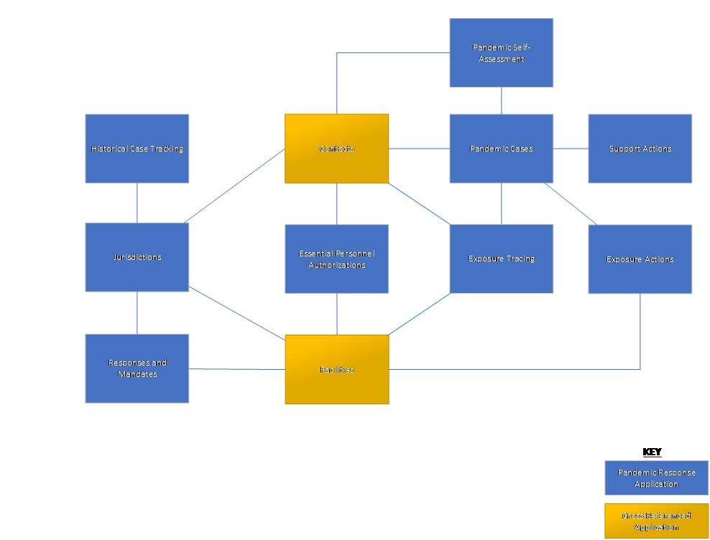

### Swim Lane diagrams

#### Pandemic self-assessment

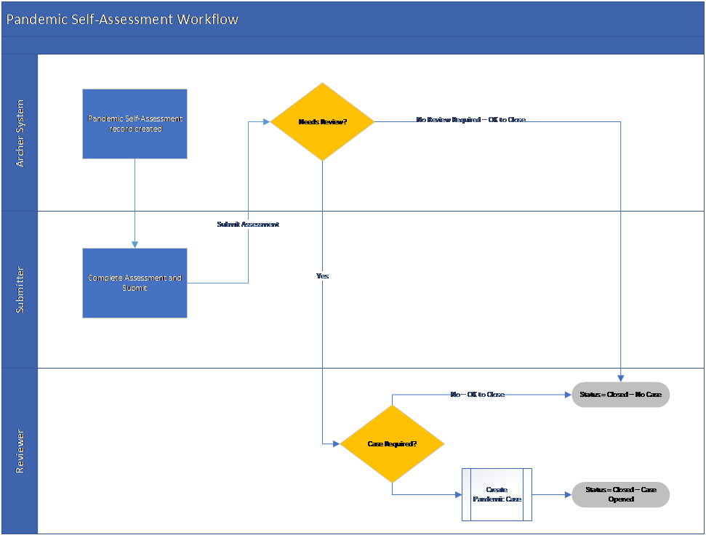

#### Pandemic cases

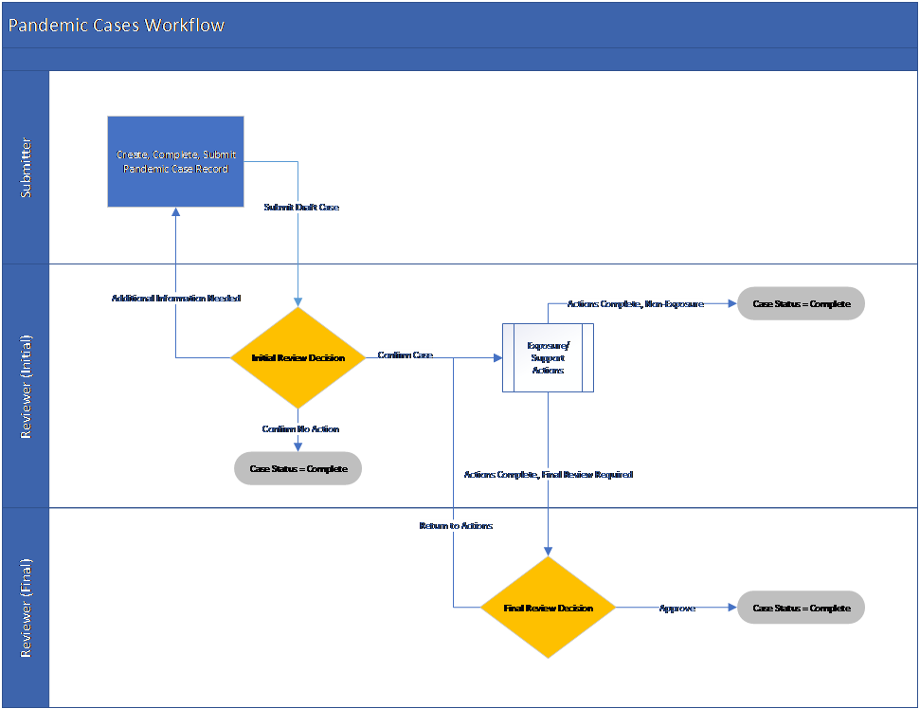

#### Exposure actions

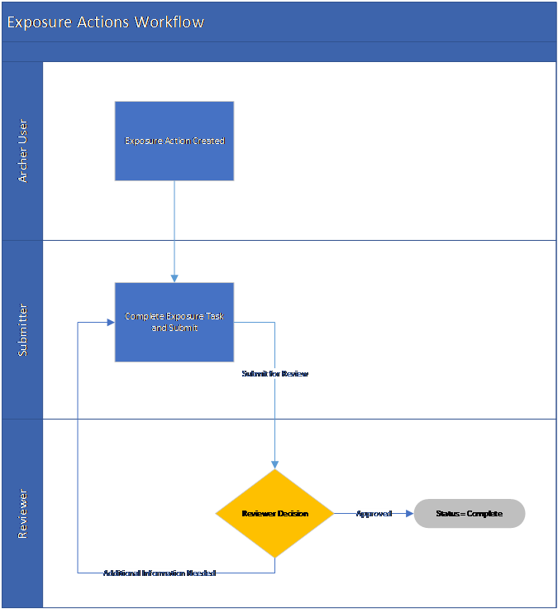

#### Support actions

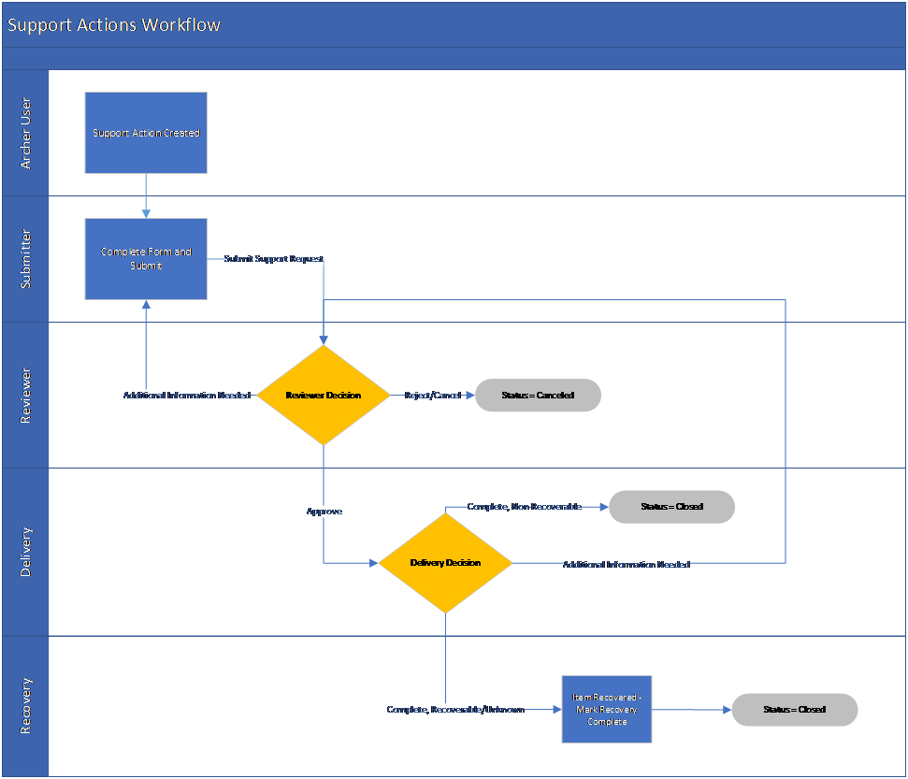

#### Essential personnel authorization

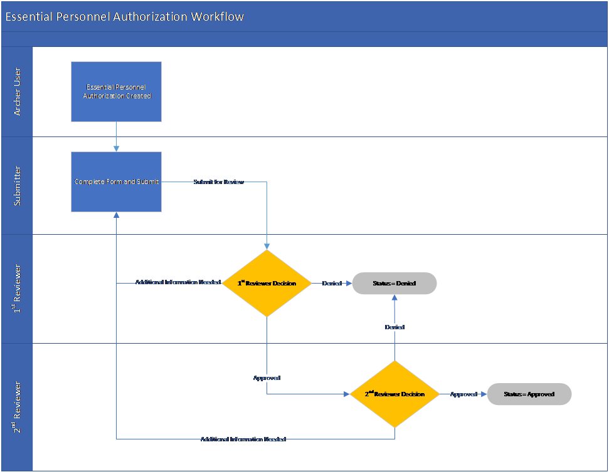

### Applications

| Solution Area | Application | Description |
| --- | --- | --- |
| Jurisdiction Management | Jurisdictions | Track relevant jurisdictions’ total and active cases, recoveries, fatalities, and other data needed to assess risks and make decisions regarding employees, vendors, customers, and facilities. Jurisdictions can include regions, countries, states, territories, cities, and counties. |
| Jurisdiction Management | Historical Case Tracking | Track daily case statistics to provide a historical view into the data set. |
| Mandate Tracking | Responses and Mandates | Track closures, shelter-in-place directives, economic actions, policy changes and other mandates and orders across various jurisdictions. |
| Exposure Management, Personnel Support | Pandemic Cases | Review information and trigger the actions needed to support employees and respond to exposures. |
| Exposure Management | Exposure Actions | Track, approve, assign and confirm actions associated with presumed or confirmed exposure, including notification, facility closure, cleaning, and more. |
| Exposure Management | Exposure Tracing | Track exposure sites and contact tracing for people known to have possible exposure. |
| Exposure Management, Personnel Support | Pandemic Self-Assessment | Survey employees to gather relevant data including location, remote office needs, work schedule changes, safety concerns, exposure status, diagnosis status, wellness, and more. Create a case and manage related actions if their answers require support or exposure tracking and management. |
| Personnel Support | Support Actions | Create and follow actions needed to support employees, including providing equipment, additional money, tangible goods, emotional support or other assistance. Track the entire workflow of an action from request, approval, delivery, and if possible, repossession from the employee, insurance, governmental programs and more. |
| Essential Personnel Authorizations | Essential Personnel Authorizations | Manage the request, approval, and communication workflow for employees or contractors that need authorization to leave their shelter-in-place location to perform essential functions. Essential employees can generate and download safe passage letters through the app. |

### Personas and Access Roles

The following table describes the functions that make up the application’s organization roles. Depending on the organization of your company, these functions and responsibilities may vary.  For detailed instructions on changes to the General User Access Role, please see Modifying the General User Access Role further in this document.

| Function | Description |
| --- | --- |
| Pandemic Response | The Pandemic Response group is the parent group for all other groups in the solution. |
| Content Administrator | The Content Administrator can create, read, update, and delete all records within the Pandemic Response applications and questionnaires. |
| Read All | The Read All user group can read all records within the Pandemic Response applications and questionnaires. |
| Essential Personnel Approvers | The Essential Personnel Approvers user group can update in-process Essential Personnel Authorizations and read all records. They can read associated Contact records that are referenced in the Essential Personnel Authorization. |
| Essential Personnel Managers | The Essential Personnel Managers group can create, read, and update Essential Personnel Authorization records. |
| Pandemic Case Managers | The Pandemic Case Manager can create, read, and update Pandemic Self-Assessments and Pandemic Cases. They can read all Contact and Facilities records. |
| Support Action Managers | The Support Action Managers user group can create, read, and update in-process Support Action records. They can read all Facilities records. |
| Support Action Reviewers | The Support Action Reviewers user group can create, read, and update (when in the Pending Review workflow stage) Support Action records. They can read all Facilities records. |
| Support Action Delivery | The Support Action Delivery user group can create, read, and update (when in the Pending Delivery workflow stage) Support Action records. They can read all Facilities records. |
| Support Action Recovery | The Support Action Recovery user group can create, read, and update (when in the Pending Recovery workflow stage) Support Action records. They can read all Facilities records. |
| Exposure Action Managers | The Exposure Action Managers user group can create, read, and update (when not in Complete status) Exposure Action records. They can read all Facilities records. |
| Exposure Action Reviewers | The Exposure Action Reviewers user group can read, and update (when in the Pending Review workflow stage) Exposure Action records. They can read all Facilities records. |
| Exposure Tracing Managers | The Exposure Tracing Managers user group can create and read all Exposure Tracing records. They can read all Facilities records. |
| Jurisdiction Managers | The Jurisdiction Managers can create, read, and update all Jurisdiction and Historical Case Tracking records. They can read all Facilities records. |
| Mandate Managers | The Mandate Managers can create, read, and update all Responses and Mandates records. |
| General Users | General Users can read all records in the Historical Case Tracking, Jurisdictions, Responses, and Mandates applications and can read records in the Contacts and Facilities applications on a per-record basis. General Users can read and update records in the Exposure Actions and Pandemic Self-Assessments applications on a per-record basis.  General Users can create records in the Pandemic Self-Assessment Questionnaire. |

## Configure core applications

This chapter documents the changes made to Contacts and Facilities (core applications) to support the Pandemic Response App-Pack.  We recommend that you use this section to review and understand the changes made to each of the applications before installing via the Pandemic Response package.  You do have the option not to install the applications via the package; however, please know that there is extensive manual configuration that needs to be done in its place.  The changes that directly impact these applications are thoroughly documented below, but indirect impact (for example, reference calculations in related applications) are not documented to the same extent.  We recommend that you install the package provided, taking any necessary precautions (perform a backup first, create new fields only, not overriding layout) to preserve your current configuration.

Each of the fields listed in this section, if not created as part of a package installation, should be created using the default configuration options unless otherwise specified.

### Task 1: Add fields to the contacts application

| Field Type | Field Name | Description | Formula | Values List Name or Values |
| --- | --- | --- | --- | --- |
| Record Permissions | Auto Permissions: Pandemic Case Managers | Automatically grants permission to the Pandemic Case Managers group. | Default Users/Groups = Pandemic Response: Case Managers (Read) |  |
| Record Permissions | Auto Permissions: Pandemic Content Admins | Automatically grants permission to the Pandemic Content Admins group. | Default Users/Groups = Pandemic Response: Content Admin (Read, Update, Delete) |  |
| Record Permissions | Auto Permissions: Pandemic Read All | Automatically grants permission to the Pandemic Read All group. | Default Users/Groups = Pandemic Response: Pandemic Read All (Read) |  |
| Text | Business County | This field displays the contact's business county. |  |  |
| Text | Business Territory | This field displays the contact's business territory. |  |  |
| Cross-Reference | Essential Personnel Authorization - Critical Equipment | This field is a cross- reference to the Essential Personnel Authorization Questionnaire which allows contacts to be selected in that form. |  |  |
| Cross-Reference | Essential Personnel Authorization - Critical Information | This field is a cross-reference to the Essential Personnel Authorization Questionnaire which allows contacts to be selected in that form. |  |  |
| Cross-Reference | Essential Personnel Authorization - Other | This field is a cross-reference to the Essential Personnel Authorization Questionnaire which allows contacts to be selected in that form. |  |  |
| Cross-Reference | Essential Personnel Authorization - Public Services | This field is a cross-reference to the Essential Personnel Authorization Questionnaire which allows contacts to be selected in that form. |  |  |
| Cross-Reference | Facilities Where Contact is Authorized as Essential Personnel | Calculated Cross-Reference to display the Facilities where the contact has an Essential Personnel Authorization approval. | See Appendix A |  |
| Cross-Reference | Active and Approved Essential Personnel Authorizations | Lists only the Essential Personnel Authorizations that are currently active and approved. | See Appendix A |  |
| Values List | Friday End Time | This calculated field gets the value of the matching field in the most recently submitted Pandemic Self-Assessment. | MOSTRECENTVALUE(REF([Pandemic Self-Assessment(s)],[Friday End Time]), REF([Pandemic Self-Assessment(s)],[Helper: Submit Date])) | GVL: End Time |
| Values List | Friday Start Time | This calculated field gets the value of the matching field in the most recently submitted Pandemic Self-Assessment. | MOSTRECENTVALUE(REF([Pandemic Self-Assessment(s)],[Friday Start Time]), REF([Pandemic Self-Assessment(s)],[Helper: Submit Date])) | GVL: Start Time |
| Values List | Helper: Authorized Essential Personnel | This helper field is a Yes/No calculated field to indicate whether the Contact is essential personnel at any Facility. | IF(COUNTA([Facilities Where Contact is Authorized as Essential Personnel]) > 0, VALUEOF([Helper: Authorized Essential Personnel],"Yes"), VALUEOF([Helper: Authorized Essential Personnel],"No")) | Yes/No |
| Text | Helper: Business Country | This helper field converts the matching values list field to text to be used as a matching mechanism for a calculated cross-reference. | [Bus. Country] |  |
| Text | Helper: Business State | This helper field converts the matching values list field to text to be used as a matching mechanism for a calculated cross-reference. | [Bus. State] |  |
| Text | Helper: Company Name | This helper field converts the matching values list field to text to be used as a matching mechanism for a calculated cross-reference. | REF([Company],[Company]) |  |
| Text | Helper: Personal Country | This helper field converts the matching values list field to text to be used as a matching mechanism for a calculated cross-reference. | [Pers. Country] |  |
| Text | Helper: Personal State | This helper field converts the matching values list field to text to be used as a matching mechanism for a calculated cross-reference. | [Pers. State] |  |
| Text | Helper: Personal State (Text) | This helper field converts the matching values list field to text to be used as a matching mechanism for a calculated cross-reference. | [Pers. State] |  |
| Text | Helper: Working Country | This helper field converts the matching values list field to text to be used as a matching mechanism for a calculated cross-reference. | [Working Country] |  |
| Text | Helper: Working State | This helper field converts the matching values list field to text to be used as a matching mechanism for a calculated cross-reference. | [Working State] |  |
| Values List | Monday End Time | This calculated field gets the value of the matching field in the most recently submitted Pandemic Self-Assessment. | MOSTRECENTVALUE(REF([Pandemic Self-Assessment(s)],[Monday End Time]), REF([Pandemic Self-Assessment(s)],[Helper: Submit Date])) | GVL: End Time |
| Values List | Monday Start Time | This calculated field gets the value of the matching field in the most recently submitted Pandemic Self-Assessment. | MOSTRECENTVALUE(REF([Pandemic Self-Assessment(s)],[Monday Start Time]), REF([Pandemic Self-Assessment(s)],[Helper: Submit Date])) | GVL: Start Time |
| Cross-Reference | Pandemic Case(s) | This field allows users to select Pandemic Case(s) where this contact is involved. |  |  |
| Text | Pers. County | This field displays the contact's personal County. |  |  |
| Text | Pers. Territory | This field displays the contact's personal Territory. |  |  |
| Values List | Saturday End Time | This calculated field gets the value of the matching field in the most recently submitted Pandemic Self-Assessment. | MOSTRECENTVALUE(REF([Pandemic Self-Assessment(s)],[Saturday End Time]), REF([Pandemic Self-Assessment(s)],[Helper: Submit Date])) | GVL: End Time |
| Values List | Saturday Start Time | This calculated field gets the value of the matching field in the most recently submitted Pandemic Self-Assessment. | MOSTRECENTVALUE(REF([Pandemic Self-Assessment(s)],[Saturday Start Time]), REF([Pandemic Self-Assessment(s)],[Helper: Submit Date])) | GVL: Start Time |
| Values List | Sunday End Time | This calculated field gets the value of the matching field in the most recently submitted Pandemic Self-Assessment. | MOSTRECENTVALUE(REF([Pandemic Self-Assessment(s)],[Sunday End Time]), REF([Pandemic Self-Assessment(s)],[Helper: Submit Date])) | GVL: End Time |
| Values List | Sunday Start Time | This calculated field gets the value of the matching field in the most recently submitted Pandemic Self-Assessment. | MOSTRECENTVALUE(REF([Pandemic Self-Assessment(s)],[Sunday Start Time]), REF([Pandemic Self-Assessment(s)],[Helper: Submit Date])) | GVL: Start Time |
| Cross-Reference | Support Action(s) |  | See Appendix A |  |
| Values List | Thursday End Time | This calculated field gets the value of the matching field in the most recently submitted Pandemic Self-Assessment. | MOSTRECENTVALUE(REF([Pandemic Self-Assessment(s)],[Thursday End Time]), REF([Pandemic Self-Assessment(s)],[Helper: Submit Date])) | GVL: End Time |
| Values List | Thursday Start Time | This calculated field gets the value of the matching field in the most recently submitted Pandemic Self-Assessment. | MOSTRECENTVALUE(REF([Pandemic Self-Assessment(s)],[Thursday Start Time]), REF([Pandemic Self-Assessment(s)],[Helper: Submit Date])) | GVL: Start Time |
| Values List | Tuesday End Time | This calculated field gets the value of the matching field in the most recently submitted Pandemic Self-Assessment. | MOSTRECENTVALUE(REF([Pandemic Self-Assessment(s)],[Tuesday End Time]), REF([Pandemic Self-Assessment(s)],[Helper: Submit Date])) | GVL: End Time |
| Values List | Tuesday Start Time | This calculated field gets the value of the matching field in the most recently submitted Pandemic Self-Assessment. | MOSTRECENTVALUE(REF([Pandemic Self-Assessment(s)],[Tuesday Start Time]), REF([Pandemic Self-Assessment(s)],[Helper: Submit Date])) | GVL: Start Time |
| Values List | Wednesday End Time | This calculated field gets the value of the matching field in the most recently submitted Pandemic Self-Assessment. | MOSTRECENTVALUE(REF([Pandemic Self-Assessment(s)],[Wednesday End Time]), REF([Pandemic Self-Assessment(s)],[Helper: Submit Date])) | GVL: End Time |
| Values List | Wednesday Start Time | This calculated field gets the value of the matching field in the most recently submitted Pandemic Self-Assessment. | MOSTRECENTVALUE(REF([Pandemic Self-Assessment(s)],[Wednesday Start Time]), REF([Pandemic Self-Assessment(s)],[Helper: Submit Date])) | GVL: Start Time |
| Cross-Reference | Work Facility | This cross reference field allows the user to select the Facility the Contact works in. |  |  |
| Text | Working Address | This calculated field gets the value of the matching field in the most recently submitted Pandemic Self-Assessment. | MOSTRECENTVALUE(REF([Pandemic Self-Assessment(s)],[Street]), REF([Pandemic Self-Assessment(s)],[Helper: Submit Date])) |  |
| Text | Working City | This calculated field gets the value of the matching field in the most recently submitted Pandemic Self-Assessment. | MOSTRECENTVALUE(REF([Pandemic Self-Assessment(s)],[City]), REF([Pandemic Self-Assessment(s)],[Helper: Submit Date])) |  |
| Values List | Working Country | This calculated field gets the value of the matching field in the most recently submitted Pandemic Self-Assessment. | MOSTRECENTVALUE(REF([Pandemic Self-Assessment(s)],[Country]), REF([Pandemic Self-Assessment(s)],[Helper: Submit Date])) | GVL: Countries |
| Text | Working County | This calculated field gets the value of the matching field in the most recently submitted Pandemic Self-Assessment. | MOSTRECENTVALUE(REF([Pandemic Self-Assessment(s)],[County]), REF([Pandemic Self-Assessment(s)],[Helper: Submit Date])) |  |
| Values List | Working State | This calculated field gets the value of the matching field in the most recently submitted Pandemic Self-Assessment. | MOSTRECENTVALUE(REF([Pandemic Self-Assessment(s)],[State]), REF([Pandemic Self-Assessment(s)],[Helper: Submit Date])) | GVL: States |
| Text | Working Territory | This calculated field gets the value of the matching field in the most recently submitted Pandemic Self-Assessment. | MOSTRECENTVALUE(REF([Pandemic Self-Assessment(s)],[Territory]), REF([Pandemic Self-Assessment(s)],[Helper: Submit Date])) |  |
| Text | Working Zip Code | This calculated field gets the value of the matching field in the most recently submitted Pandemic Self-Assessment. | MOSTRECENTVALUE(REF([Pandemic Self-Assessment(s)],[Zip Code]), REF([Pandemic Self-Assessment(s)],[Helper: Submit Date])) |  |
| Values List | Pandemic Self-Assessment Frequency | This field is used to select at what frequency the user should be sent a Pandemic Self-Assessment. | Select ENABLE BULK UPDATE and ALLOW THIS FIELD TO BE EDITABLE IN SEARCH RESULTS | Adhoc / Manual Daily Every 2 Days Weekly |
| Date | Helper: Date of Initial Frequency Setting | This field is used to store the date when the first frequency selection was made. | IF(NOT(ISEMPTY([Helper: Date of Initial Frequency Setting])),[Helper: Date of Initial Frequency Setting],  IF(CONTAINS(ANY,[Pandemic Self-Assessment Frequency],VALUEOF([Pandemic Self-Assessment Frequency],"Daily","Every 2 Days","Weekly")),TODAY(),"")) |  |
| Values List | Trigger Instant Pandemic Self-Assessment? | This field is used to indicate a Pandemic Self-Assessment be sent to the user instantly. | Select Enable Bulk Update and Allow this Field to be Editable in Search Results | Yes/No |
| Date | Helper: Date of Last Pandemic Self-Assessment Creation | This field is calculated to identify the most recent date a Pandemic Self-Assessment was sent to the user. | MAXA(REF([Pandemic Self-Assessment(s)],[Helper: Created Date])) |  |
| Values List | Helper: Trigger Scheduled Self-Assessment? | This helper field calculates when a scheduled Pandemic Self-Assessment should be triggered and sets the value to Yes. | IF(ISEMPTY([RSA Archer User Account]),VALUEOF([Helper: Trigger Scheduled Self-Assessment?],"No"),    IF(ISEMPTY([Date of Next Scheduled Self-Assessment Creation]),VALUEOF([Helper: Trigger Scheduled Self-Assessment?],"No"),    IF([Helper: Date of Last Pandemic Self-Assessment Creation]=TODAY(),VALUEOF([Helper: Trigger Scheduled Self-Assessment?],"No"),    IF(TODAY()>=[Date of Next Scheduled Self-Assessment Creation],  VALUEOF([Helper: Trigger Scheduled Self-Assessment?],"Yes"),  VALUEOF([Helper: Trigger Scheduled Self-Assessment?],"No"))))) | Yes/No |
| Date | Date of Last Scheduled Assessment Creation | This field holds the last date a scheduled assessment was created. | MAXA(REF([Pandemic Self-Assessment(s)],[Helper: Scheduled Creation Day])) |  |
| Date | Date of Last Instant/Adhoc Self-Assessment | This helper field calculates the last date/time an instant Pandemic Self-Assessment was sent. | MAXA(REF([Pandemic Self-Assessment(s)],[Helper: Date/Time of Instant Creation])) |  |
| Text | Google Map (Working) | This calculated field provides a Google Map hyperlink. When the user clicks this link, Google Map integration opens a new browser window and automatically generates a search query using the geo-related data such as the address, city, state and Zip code. Once the search is generated, users are then presented with a map of the location that they were searching for. | "<a target='_new' href='http://maps.google.com/maps?f=q&ie=UTF8&om=1&hl=en&q=" & [Working Address] & ", " & [Working City] & ", " & [Working State] & ", " & [Working Zip Code] & "'>Google Map - Working Address</a>" |  |
| Values List | Helper: Trigger Instant Self-Assessment? | This helper field calculates when an instant Pandemic Self-Assessment should be triggered and sets the value to Yes. | IF(ISEMPTY([RSA Archer User Account]),VALUEOF([Helper: Trigger Instant Self-Assessment?],"No"),    IF(OR(ISEMPTY([Trigger Instant Pandemic Self-Assessment?]),CONTAINS(EXACT,[Trigger Instant Pandemic Self-Assessment?],VALUEOF([Trigger Instant Pandemic Self-Assessment?],"No"))),  VALUEOF([Helper: Trigger Instant Self-Assessment?],"No"),    IF([Helper: Date of Last Pandemic Self-Assessment Creation]=TODAY(),  VALUEOF([Helper: Trigger Instant Self-Assessment?],"No"),    IF(CONTAINS(EXACT,[Trigger Instant Pandemic Self-Assessment?],VALUEOF([Trigger Instant Pandemic Self-Assessment?],"Yes")),  VALUEOF([Helper: Trigger Instant Self-Assessment?],"Yes"),    VALUEOF([Helper: Trigger Instant Self-Assessment?],"No"))))) | Yes/No |
| Date | Date of Last Instant/Adhoc Self-Assessment | This helper field calculates the last date/time an instant Pandemic Self-Assessment was sent. | MAXA(REF([Pandemic Self-Assessment(s)],[Helper: Instant Creation Day])) |  |
| Date | Date of Last Scheduled Assessment Creation | This helper field calculates the last date a scheduled assessment was sent. | MAXA(REF([Pandemic Self-Assessment(s)],[Helper: Scheduled Creation Day])) |  |
| Date | Date of Next Scheduled Self-Assessment Creation | This field is calculated to identify when the next Pandemic Self-Assessment will be sent to the user. | IF(NOT(ISEMPTY([Date of Last Scheduled Assessment Creation])),    IF(CONTAINS(EXACT,[Pandemic Self-Assessment Frequency],VALUEOF([Pandemic Self-Assessment Frequency],"Daily")),DATEADD(DAY,1,[Date of Last Scheduled Assessment Creation]),    IF(CONTAINS(EXACT,[Pandemic Self-Assessment Frequency],VALUEOF([Pandemic Self-Assessment Frequency],"Every 2 Days")),DATEADD(DAY,2,[Date of Last Scheduled Assessment Creation]),    IF(CONTAINS(EXACT,[Pandemic Self-Assessment Frequency],VALUEOF([Pandemic Self-Assessment Frequency],"Weekly")),DATEADD(DAY,7,[Date of Last Scheduled Assessment Creation]),    ""))),      IF(CONTAINS(EXACT,[Pandemic Self-Assessment Frequency],VALUEOF([Pandemic Self-Assessment Frequency],"Daily")),DATEADD(DAY,1,[Helper: Date of Initial Frequency Setting]),    IF(CONTAINS(EXACT,[Pandemic Self-Assessment Frequency],VALUEOF([Pandemic Self-Assessment Frequency],"Every 2 Days")),DATEADD(DAY,2,[Helper: Date of Initial Frequency Setting]),    IF(CONTAINS(EXACT,[Pandemic Self-Assessment Frequency],VALUEOF([Pandemic Self-Assessment Frequency],"Weekly")),DATEADD(DAY,7,[Helper: Date of Initial Frequency Setting]),    "")))) |  |

### Task 2: Adjust the calculation order in the contacts application

Arrange the new fields in the Calculation Order to the order below.

**Note:** These can be anywhere in the order of existing calculations (first, middle, or last) but the five fields need to be in this precise order to function properly.

1. Helper: Date of Initial Frequency Setting
2. Helper: Date of Last Pandemic Self-Assessment Creation
3. Date of Last Instant/Adhoc Self-Assessment
4. Date of Last Scheduled Assessment Creation
5. Date of Next Scheduled Self-Assessment Creation
6. Helper: Trigger Instant Self-Assessment
7. Helper: Trigger Scheduled Self-Assessment

### Task 3: Set a daily calculation schedule in the contacts application

This can be recalculated at any time you choose, and 4:00 a.m. was used as an example.

### Task 4: Add fields to the layout in the contacts application

1. Add a tab to the existing Contact Information tab set and name it “Pandemic Response”.  If you have an earlier version of the Contacts application and do not have this tab set, go to the next step.
2. Create a new tab set named “Pandemic Response” and place it on the tab you created in step 1. If you skipped step 1, place the tab set wherever you would like on your layout.
3. Add three tabs to the Pandemic Response tab set:
   * General Information
   * Temporary Work Details
   * Related Pandemic Detail
4. Arrange new fields according to the images below.  Same related record fields may need to be renamed.
   * General Information

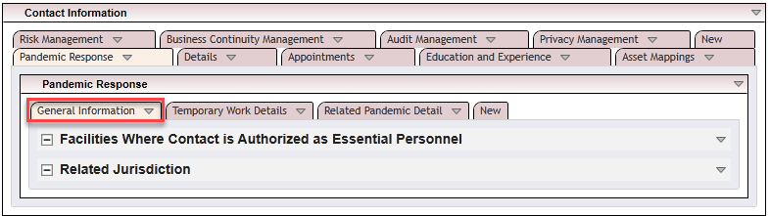

* Temporary Work Details

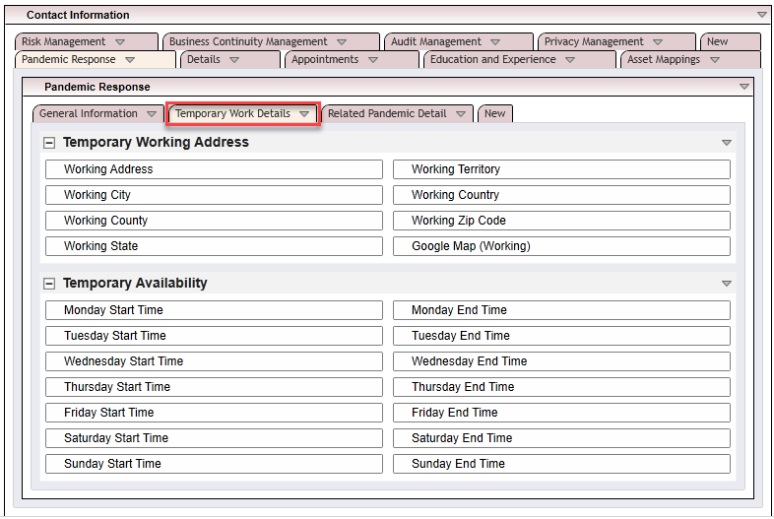

* Related Pandemic Detail

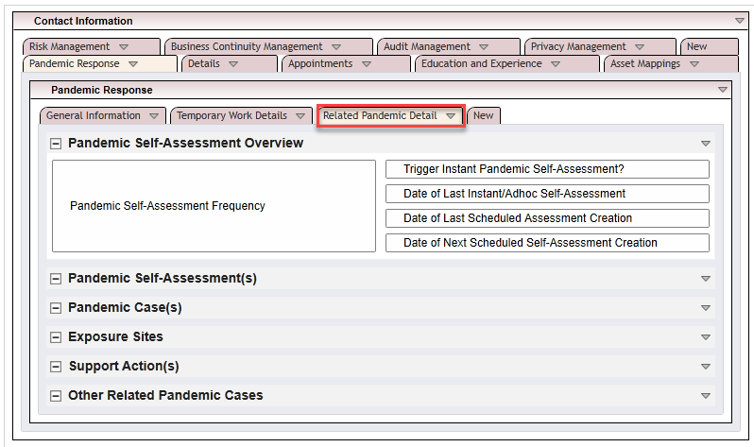

1. If you installed Contacts from the Pandemic Response package, but chose not to override layout, put the Pandemic Response Custom Objects on the layout.
   1. Essential Personnel Authorization custom object should be placed at the top of the General Information section.
   2. Locate IT custom object should be on the layout, but not visible to users (for example, in an Administration Section).
   3. Banner Source custom object should be on the layout, but not visible to users (for example, in an Administration Section).
2. Any remaining fields that were created to support Pandemic Response should be on the layout and only visible to administration users.

### Task 5: Setup bulk action schedule

Refer to setting up Schedules in Chapter 3.

### Task 6: Add fields to the facilities application

| Field Type | Field Name | Description | Formula | Values List Name or Values |
| --- | --- | --- | --- | --- |
| Cross-Reference | Approved Essential Personnel Authorizations | This calculated field creates a link to Essential Personnel Authorizations that are approved. | See Appendix B |  |
| Record Permissions | Auto Permissions: Pandemic Content Administrators | Automatically grants permission to the Pandemic Content Administrators group. | Default Users/Groups = Pandemic Response: Content Admin (Read, Update, Delete) |  |
| Record Permissions | Auto Permissions: Pandemic Response | Automatically grants permission to the Pandemic Response group. | Default Users/Groups = Pandemic Response (Read, Cascade) |  |
| Numeric | Count Critical Equipment | This field is a calculated total of Essential Personnel Authorizations for the category. | SUM(REF([Essential Personnel Authorizations (Pending and Approved)],[Count Critical Equipment])) |  |
| Numeric | Count Critical Information | This field is a calculated total of Essential Personnel Authorizations for the category. | SUM(REF([Essential Personnel Authorizations (Pending and Approved)],[Count Critical Information])) |  |
| Numeric | Count Other Essential | This field is a calculated total of Essential Personnel Authorizations for the category. | SUM(REF([Essential Personnel Authorizations (Pending and Approved)],[Count Other Essential])) |  |
| Numeric | Count Public Services | This field is a calculated total of Essential Personnel Authorizations for the category. | SUM(REF([Essential Personnel Authorizations (Pending and Approved)],[Count Public Services])) |  |
| Numeric | Count Essential Personnel (Total) | This field is a calculated total of all four Essential Personnel Categories. | SUM([Count Critical Equipment],[Count Critical Information],[Count Other Essential],[Count Public Services]) |  |
| Text | County | This field displays the county of the Facility. |  |  |
| Text | Territory | This field displays the territory of the Facility. |  |  |
| Cross-Reference | Essential Personnel Authorizations (Pending and Approved) | This field is a calculated cross-reference to Essential Personnel Authorizations that are Pending and Approved. | See Appendix B |  |
| Text | Helper: Country | This helper field converts the matching values list field to text to be used as a matching mechanism for a calculated cross-reference. | [Country] |  |
| Text | Helper: Jurisdiction Facilities Match City State | This field concatenates the city and state to match against Jurisdictions. | CONCATENATE([City],", ",[State]) |  |
| Text | Helper: Jurisdiction Facilities Match Country | This helper field converts the matching values list field to text to be used as a matching mechanism for a calculated cross-reference. | [Country] |  |
| Text | Helper: Jurisdiction Facilities Match County | This field concatenates the county and state to match against Jurisdictions. | CONCATENATE([County],", ",[State]) |  |
| Text | Helper: Jurisdiction Facilities Match State | This helper field converts the matching values list field to text to be used as a matching mechanism for a calculated cross-reference. | [State] |  |
| Text | Helper: Jurisdiction Facilities Match Territory | This helper field converts the matching values list field to text to be used as a matching mechanism for a calculated cross-reference. | [Territory] |  |
| Values List | Helper: Lockdown Status | This calculated helper field indicates whether the Facility is in a Jurisdiction that has a mandated lockdown. | IF(REF([Pandemic Jurisdictions],[Helper: Lockdown in Effect]) = VALUEOF(REF([Pandemic Jurisdictions],[Helper: Lockdown in Effect]),"No Lockdowns in this Jurisdiction"), VALUEOF([Helper: Lockdown Status],"None"),  IF(AND(REF([Pandemic Jurisdictions],[Helper: Lockdown in Effect]) = VALUEOF(REF([Pandemic Jurisdictions],[Helper: Lockdown in Effect]),"Active Lockdown in this Jurisdiction"), [Helper: Closure Confirmed] = VALUEOF([Helper: Closure Confirmed],"No")), VALUEOF([Helper: Lockdown Status],"Pending"),  IF(AND(REF([Pandemic Jurisdictions],[Helper: Lockdown in Effect]) = VALUEOF(REF([Pandemic Jurisdictions],[Helper: Lockdown in Effect]),"Active Lockdown in this Jurisdiction"), [Helper: Closure Confirmed] = VALUEOF([Helper: Closure Confirmed],"Yes")), VALUEOF([Helper: Lockdown Status],"Confirmed")))) | Confirmed, None, Pending |
| Tracking ID | System Tracking ID | The System Tracking ID field is a system-wide unique ID of the record with no prefixes or suffixes. |  |  |
| Text | Helper: Record Tracking ID | This helper field converts the matching values list field to text to be used as a matching mechanism for a calculated cross-reference. | [System Tracking ID] |  |
| Text | Helper: State Name | This helper field converts the matching values list field to text to be used as a matching mechanism for a calculated cross-reference. | [State] |  |
| Text | Hospital ID | This field displays the Hospital ID. |  |  |
| Values List | Hospital Type | This field allows the user to select the hospital type. |  | Acute Care - Department of Defense; Acute Care Hospitals; Children; Critical Access Hospitals; Psychiatric |
| Record Permissions | Inherited Permissions: Essential Personnel | This field inherits permissions from the Essential Personnel Authorization Questionnaire. | Inherited, Unrestricted - Essential Personnel Authorizations/Inherited Permissions: Contact |  |
| Values List | Lockdown Status | This field allows the user to select the lockdown status of the facility. |  | Closed at Business Discretion; Closed Due to Lockdown; Remain Open - Essential Facility |
| Values List | Helper: Closure Confirmed | This calculated helper field indicates whether the closure of the facility is confirmed. | IF([Lockdown Status] = VALUEOF([Lockdown Status],"Closed Due to Lockdown"), VALUEOF([Helper: Closure Confirmed],"Yes"), VALUEOF([Helper: Closure Confirmed],"No")) | Yes/No |

### Task 7: Add fields to the layout in the facilities application

1. Add a tab to the existing Facility Information tab set and name it “Pandemic Response”.  If you have an earlier version of the Facilities application and do not have this tab set, go to the next step.

* 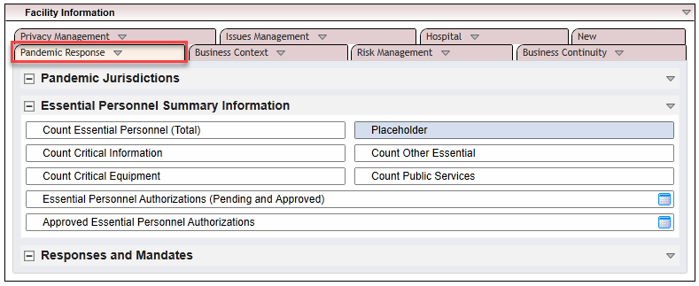

1. Arrange new fields according to the image above.

* **Note:** Same related record fields may need to be renamed.

1. If you installed Facilities from the Pandemic Response package, but chose not to override layout, put the Pandemic Response Custom Objects on the layout.
   1. Facility Closed custom object at the top of the General Information section.
   2. Place Facility Closed by Owner custom object second to the top of the General Information section.
   3. Place Facility Pending Closure custom object third to the top of the General Information section.
   4. Place No Lockdown or Closure custom object fourth to the top of the General Information section.
   5. Place Essential Employees Only_id_2556236 custom object fifth to the top of the General Information section.
   6. Locate IT custom object should be on the layout, but not visible to users (for example, in an Administration Section).
   7. Banner Source custom object should be on the layout, but not visible to users (for example, in an Administration Section).
2. Put any remaining fields that were created to support Pandemic Response on the layout and only visible to administration users.

## Installing Pandemic Response

### Installation overview

Complete the following tasks to install the application.

#### Step 1: Prepare for the installation

1. Ensure that your Archer system meets the following requirements:
   * Archer Platform version 6.4 HF1 (6.4.00001.1000) or later
2. Download the ODA install package from the Archer Exchange on:(https://community.rsa.com/community/products/archer- grc/archer-61/downloads).
3. Obtain the Data Dictionary for the ODA by contacting your Archer Account Representative or calling 1-888-539-EGRC. The Data Dictionary contains the configuration information for the use case.
4. Read and understand the "Packaging Data" section of Archer Help.

#### Step 2: Install the package

Installing a package requires that you import the package file, map the objects in the package to objects in the target instance, and then install the package. See Installing the Application Package for complete information.

#### Step 3: Set up data feeds

You must import and schedule each use case data feed that you want to use. See Setting Up Data Feeds for complete information.

#### Step 4: Test the installation

Test the application according to your company standards and procedures, to ensure that the use case works with your existing processes.

### Installing the package

#### Task 1: Back up your database

There is no Undo function for a package installation. Packaging is a powerful feature that can make significant changes to an instance. Archer strongly recommends backing up the instance database before installing a package. This process enables a full restoration if necessary.

An alternate method for undoing a package installation is to create a package of the affected objects in the target instance before installing the new package. This package provides a snapshot of the instance before the new package is installed, which can be used to help undo the changes made by the package installation. New objects created by the package installation must be manually deleted.

#### Task 2: Import the package

1. Go to the Install Packages page.
   1. From the menu bar, click Admin menu.
   2. Under Application Builder, click Install Packages.
2. In the Available Packages section, click Import.
3. Click Add New, then locate and select the package file that you want to import.
4. Click OK.

The package file is displayed in the Available Packages section and is ready for installation.

#### Task 3: Map objects in the package

**Important:** This step is required only if you are upgrading to a later version of Pandemic Response.

1. In the Available Packages section, select the package you want to map.
2. In the Actions column, click  for that package.

The analyzer runs and examines the information in the package. The analyzer automatically matches the system IDs of the objects in the package with the objects in the target instances and identifies objects from the package that are successfully mapped to objects in the target instance, objects that are new or exist but are not mapped, and objects that do not exist (the object is in the target but not in the source).

**Note:** This process can take several minutes or more, especially if the package is large, and may time out after 60 minutes. This time-out setting temporarily overrides any IIS time-out settings set to less than 60 minutes.

When the analyzer is complete, the Advanced Package Mapping page lists the objects in the package file and corresponding objects in the target instance. The objects are divided into tabs, depending on whether they are found within Applications, Solutions, Access Roles, Groups, Sub- forms, or Questionnaires.

1. On each tab of the Advanced Mapping Page, review the icons that are displayed next to each object name to determine which objects require you to map them manually.

| Icon | Name | Description |
| --- | --- | --- |
| Awaiting mapping review | Awaiting Mapping Review | Indicates that the system could not automatically match the object or children of the object to a corresponding object in the target instance.  Objects marked with this symbol must be mapped manually through the mapping process.  **Important:** New objects should not be mapped. This icon should remain visible. The mapping process can proceed without mapping all the objects.  **Note:** You can execute the mapping process without mapping all the objects. The Awaiting mapping review icon is for informational purposes only. |
| Checkmark | Mapping  Completed | Indicates that the object and all child objects are mapped to an object in the target instance. Nothing more needs to be done with these objects in Advanced Package Mapping. |
| Missing objects | Do Not  Map | Indicates that the object does not exist in the target instance or the object was not mapped through the Do Not Map option. These objects will not be mapped through Advanced Package Mapping, and must be remedied manually. |
|  | Undo | Indicates that a mapped object can be unmapped. This icon is displayed in the Actions column of a mapped object or object flagged as Do Not Map. |

1. For each object that requires remediation, do one of the following:
   * To map each item individually, on the Target column, select the object in the target instance to which you want to map the source object. If an object is new or if you do not want to map an object, select Do Not Map from the drop-down list.
   * **Important:** Ensure that you map all objects to their lowest level. When objects have child or related objects, a drill-down link is provided on the parent object. Child objects must be mapped before parent objects are mapped. For more details, see "Mapping Parent/Child Objects" in Archer Help.
   * To automatically map all objects in a tab that have different system IDs but the same object name as an object in the target instance, do the following:
   1. In the toolbar, click Auto Map.
   2. Select an option for mapping objects by name.

| Option | Description |
| --- | --- |
| Ignore case | Select this option to match objects with similar names regardless of the case of the characters in the object names. |
| Ignore spaces | Select this option to match objects with similar names regardless of whether spaces exist in the object names. |

* 1. Click OK.
  + The Confirmation dialog box opens with the total number of mappings performed. These mappings have not been committed to the database yet and can be modified in the Advanced Package Mapping page.
  1. Click OK.
* To set all objects in the tab to Do Not Map, in the toolbar, click Do Not Map.

**Note:** To undo the mapping settings for any individual object, click  in the Actions column.

When all objects are mapped, the Checkmark icon is displayed in the tab title. The Missing objects icon is displayed next to the object to indicate that the object will not be mapped.

1. Verify that all other objects are mapped correctly.
2. (Optional) To save your mapping settings so that you can resume working later, see"Exporting and Importing Mapping Settings" in Archer Help .
3. Once you have reviewed and mapped all objects, click .
4. Select I understand the implications of performing this operation and click OK.

The Advanced Package Mapping process updates the system IDs of the objects in the target instance as defined on the Advanced Package Mapping page. When the mapping is complete, the Import and Install Packages page is displayed.

**Important:** Advanced Package Mapping modifies the system IDs in the target instance. Any Data Feeds and Web Service APIs that use these objects will need to be updated with the new system IDs.

#### Task 4: Install the package

All objects from the source instance are installed in the target instance unless the object can not be found or is flagged to not be installed in the target instance. A list of conditions that may cause objects not to be installed is provided in the Log Messages section. A log entry is displayed in the Package Installation Log section.

1. Go to the Install Packages page.
   1. From the menu bar, click Admin menu.
   2. Under Application Builder, click Install Packages.
2. In the Available Packages section, locate the package file that you want to install, and click Install.
3. In the Configuration section, select the components of the package that you want to install.
   * To select all components, select the top-level checkbox.
   * To install only specific global reports in an already installed application, select the checkbox associated with each report that you want to install.

**Note:** Items in the package that do not match an existing item in the target instance are selected by default.

1. In the Configuration section, under Install Method, select an option for each selected component. To use the same Install Method for all selected components, select a method from the top-level drop-down list.

**Note:** If you have any existing components that you do not want to modify, select Create New Only. You may have to modify those components after installing the package to use the changes made by the package.

1. In the Configuration section, under Install Option, select an option for each selected component. To use the same Install Option for all selected components, select an option from the top-level drop-down list.

**Note:** If you have any custom fields or formatting in a component that you do not want to lose, select Do not Override Layout. You may have to modify the layout after installing the package to use the changes made by the package.

1. To deactivate target fields and data-driven events that are not in the package, in the Post-Install Actions section, select the Deactivate target fields and data-driven events that are not in the package check box. To rename the deactivated target fields and data-driven events with a user-defined prefix, select the Apply a prefix to all deactivated objects check box, and enter a prefix. This can help you identify any fields or data-driven events that you may want to review for cleanup post-install.
2. Click Install.
3. Click OK.

#### Task 5: Review the package installation log

1. Go to the Package Installation Log tab of the Install Packages page.
   1. From the menu bar, click Admin menu.
   2. Under Application Builder, click Install Packages.
   3. Click the Package Installation Log tab.
2. Click the package that you want to view.
3. In the Package Installation Log page, in the Object Details section, click View All Warnings.

* **Note:** Package installation does not place the Pandemic Response groups inside the parent Pandemic Response Group.  If you would like to nest the all of the Pandemic Response groups into the single Pandemic Response parent group, you will need to do so manually.

#### Task 6: Activate workflow

1. Go to the Manage Applications page.
   1. From the menu bar, click Admin menu.
   2. Under Application Builder, click Applications.
2. In the Applications section, select the ‘Pandemic Cases’ Application.
3. On the Advanced Workflow Tab, click Activate in the top right corner of the page.
4. Click Save Workflow in the top left corner of the page.
5. Go to the Manage Questionnaires page.
   1. From the menu bar, click Admin menu.
   2. Under Application Builder, click Questionnaires.
6. In the Questionnaires section, select the ‘Essential Personnel Authorization’, ‘Exposure Actions’, ‘Pandemic Self-Assessments’ and ‘Support Actions’.
7. On the Advanced Workflow Tab, click Activate in the top right corner of the page.
8. Click Save Workflow in the top left corner of the page.
9. Repeat Step 7 and Step 8 for each questionnaire mentioned in step 6.

#### Task 7: Setting up schedules

If the Contacts application was not installed with the Package, you will need first complete the tasks in Chapter 3, before proceeding with this section.  If the Contacts application was installed with the Package, the Bulk Action Schedule listed below will automatically be created, and you can continue with the tasks in the section.

1. Go to the Manage Schedules page.
   1. From the menu bar, click Admin menu
   2. Under Application Builder, click Schedules
2. In the Manage Bulk Action Schedules section, do one of the following:
   1. Click Set Value: Trigger Instant Pandemic Self-Assessment to No
   * Or
   1. Click Add New
3. Ensure the following:
   1. Name is set to Set Value: Trigger Instant Pandemic Self-Assessment to No
   2. Status is set to Active
   3. Application is set to Contacts
   4. Frequency is set to Hourly
   5. Every is set to 1
   6. Start Time is at the top of the nearest hour, upon creating the schedule
   7. Start Date is set to the current day, upon creating the schedule
   8. Time Zone is set to the desired setting
4. Set the following Filter
   1. Field to Evaluate is set to Trigger Instant Pandemic Self-Assessment
   2. Operator is set to Contains
   3. Values is set to Yes
5. Click Save
6. In the Bulk Actions section do one of the following:
   1. Click the existing Name of Set Value: Trigger Instant Pandemic Self-Assessment to No
   * Or
   1. Click Add New
7. Ensure the following:
   1. Name is set to “Set Value: Trigger Instant Pandemic Self-Assessment to No"
   2. Type is set to Bulk Update
   3. Field Value Expression has one entry where the Field is set to Trigger Instant Pandemic Self-Assessment?, and the Value(s) is set to No
8. Click Save
9. Click X in the top-right corner to exit the Manage Bulk Action page
10. Click Save on the Manage Bulk Schedule
11. Click X in the top-right corner to exit the Manage Bulk Schedule page

#### Task 8: Setting up data feeds

Import the data feeds in the following order using the instructions below for each data feed:

1. COVIDTracking Data Scores – This feed populates data reliability scoring on the About the Data tab in the Jurisdictions application.
2. COVIDTracking State Info – This feed populates the websites, Twitter accounts, and any data notes on the About the Data tab in the Jurisdictions application.
3. COVIDTracking State Statistics – This feed populates the Historical Case Tracking application with statistics.  This is the only source of data for that application.
4. Retrieve Responses and Mandates File – This feed populates the Responses and Mandates application with information gathered by Crowe LLP.

#### Import a data feed

1. Go to the Manage Data Feeds page.
   1. From the menu bar, click Admin menu.
   2. Under Integration, click Data Feeds.
2. In the Manage Data Feeds section, click Import.
3. Locate and select the .dfx5 file for the data feed.
4. From the General tab in the General Information section, in the Status field, select Active.
5. If your Archer environment is hosted by Archer or your Archer server uses a proxy to reach the internet, ensure the Proxy Options field is set to Use System Proxy on the Transport tab.
6. Click Save.

#### Task 9. Modifying the general user access role

To modify the General User Access Role to support Pandemic Response, please follow the instructions below.  For the Facilities and Contacts applications, the settings here represent least privilege access for Pandemic Response as designed.

1. Go to the Manage Data Feeds page.
   1. From the menu bar, click Admin menu.
   2. Expand Access Control
   3. Click Access Roles
2. Locate the Access Role named “General User” and click on it to open it. If you are unable to locate it, please speak with your Archer System Administrator, as it is possible the name of the role has been changed.
3. Click on the Rights tab.
4. Filter for Pandemic Response applications.
   1. Hover to the right of the arrow next to Solution until you see the filter funnel.
   2. Click on the filter funnel.
   3. Leave the drop-down box as Contains and type Pandemic in the empty field and click Filter.
5. Select the appropriate access for each application based on the images below.
   * Contacts

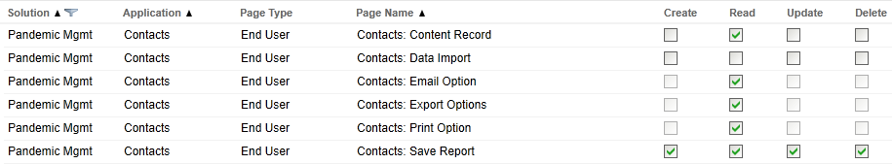

* Exposure Actions

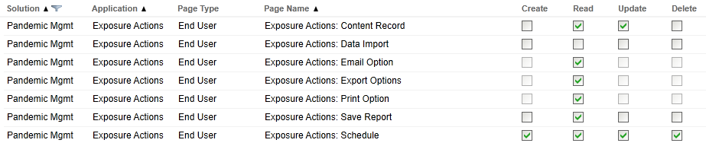

* Facilities

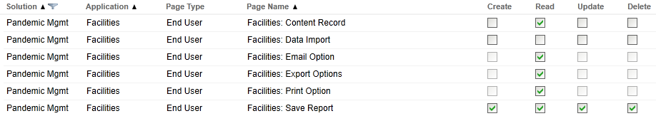

* Historical Case Tracking

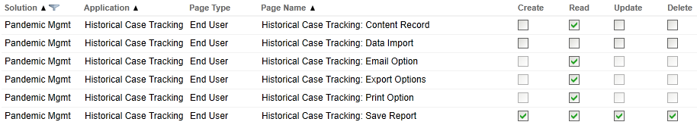

* Jurisdictions

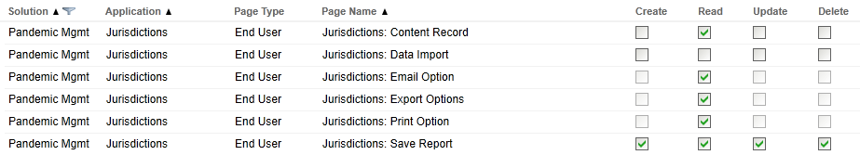

* Pandemic Self-Assessment

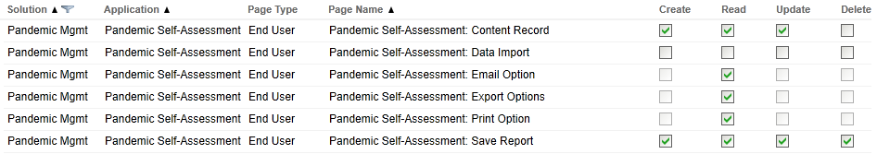

* Responses and Mandates

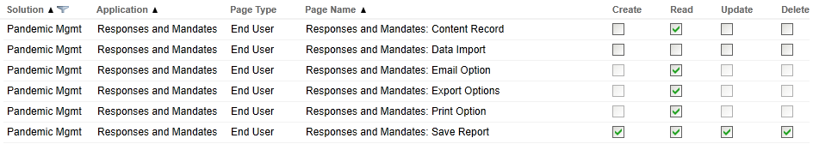

* Essential Personnel Authorization

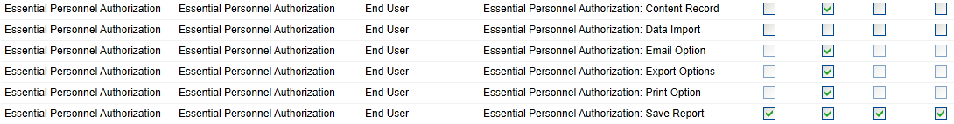

#### Task 10: Validating dashboards

The Pandemic Response solution contains custom dashboards provided by Crowe LLP.  While the dashboards work without modification for most, validate that the links are working properly.  If you encounter any errors using Pandemic Response dashboards please check if either (or both) of the following is true, and then contact [irm.support@crowe.com](mailto:irm.support@crowe.com) with the information below so that we may provide you with new links:

1. You have /archer in your URL
2. Your module/dashboard IDs do not match what is in the package.  See the table below for reference.

| ID | Type | Name |
| --- | --- | --- |
| 69 | Application | Facilities |
| 84 | Application | Contacts |
| 510 | Application | Jurisdictions |
| 511 | Application | Responses and Mandates |
| 514 | Application | Exposure Tracing |
| 517 | Application | Pandemic Cases |
| 106 | Dashboard | U.S. Country Summary |
| 107 | Dashboard | News and Announcements |
| 108 | Dashboard | Covid-19 Main |
| 113 | Dashboard | Mandate Tracking |
| 114 | Dashboard | Help |
| 115 | Dashboard | U.S. Jurisdictions |
| 116 | Dashboard | Facility Management |
| 117 | Dashboard | Personnel Support & Contact Management |
| 118 | Dashboard | Case & Exposure Management |
| 119 | Dashboard | Personnel |
| 120 | Dashboard | Pandemic Case Monitoring |
| 512 | Questionnaire | Pandemic Self-Assessment |
| 515 | Questionnaire | Historical Case Tracking |
| 518 | Questionnaire | Exposure Actions |
| 520 | Questionnaire | Essential Personnel Authorizations |
| 521 | Questionnaire | Support Actions |

## Using Pandemic Response

This chapter details procedures necessary to   use Crowe’s Pandemic Response App.

### Task 1: Navigation

Go to records within the solution using one of the following methods:

1. Click the icon on the Pandemic Response Activity Driven Dashboard.
2. Use the Workspace menu to go to the Crowe Pandemic Response workspace and the applicable Solution and Application.
3. If you have received an email notification to act or submit a form related to Pandemic Response, use the link in the email to access the workspace or record.

### Archer user accounts

#### Task 1: Adding/Managing user accounts

The Content Administrator role allows users to add and manage user accounts, including adding or editing user roles.

1. From the Administration menu, select the Users option.
2. The Manage Users page will display. To add a new user account, click Add New in the upper, right corner. To modify an existing user accounts, select the appropriate user from the listing.
3. When adding a new user, complete fields on the General Information tab: First Name, User Name, Last Name, Default Email, and Password.
4. To add or modify access to the user account, click the Groups tab at the top of the page. Click Lookup. Add the appropriate groups and click OK. Information regarding groups can be found in the Personas and Access Roles. By selecting the appropriate group, related roles will automatically be added to the user account.
5. Click Save or Save and Close to apply the changes.

### Facilities and contacts

#### Task 1: Adding a new facilities record

1. From the COVID-19 Main dashboard, click Facility Management. From the Personnel Facility Management menu, click New Facility.
2. Complete the applicable fields.
3. Click Save or Save and Close to establish the record.

#### Task 2: Adding a new contact record

1. From the COVID-19 Main dashboard, click Personnel Support & Contact Management. From the Personnel Support & Contact Management dashboard, click New Contact.
2. Complete the required fields. Use the Ellipses Lookup function to associate the record to an Archer User Account.
3. Click Save or Save and Close to save the record.

### Jurisdictions, responses and mandates

#### Task 1: Review jurisdictions and mandates

1. Click U.S. Jurisdictions from the Pandemic Response Activity Driven Dashboard.
2. Review Jurisdiction data from the COVID-19 Main dashboard.

#### Task 2: Create a new jurisdiction

1. Click New Jurisdiction from the Jurisdictions and Mandate Tracking dashboard.
2. Populate applicable information and click Save.

#### Task 3: Create a new mandate record

1. Click New Mandate from the Jurisdictions and Mandate Tracking dashboard.
2. Populate applicable information and click Save.

### Pandemic cases

#### Task 1: Create and submit a pandemic case

1. Create a new Pandemic Case record utilizing one of the methods in the Navigation section of this document.
2. Complete the applicable fields.

* **Note:** Selecting Case Source and Case Type will dynamically change the layout of the record and require applicable information.

1. Click Add New to create a new Pandemic Self-Assessment. Click the Lookup function to associate an existing Pandemic Self-Assessment. For additional information related to the Pandemic Self-Assessment process, go to the Pandemic Self-Assessments section.
2. Once all information has been entered, go to the Submission section at the bottom of the record. Change the Submitter Decision field to Ready to Submit.
3. Click Submit Draft Case at the top of the record.

#### Task 2: Perform initial review of a pandemic case

1. Go to the applicable record using one of the methods identified in the Navigation section.
2. Go to the Initial Review section of the record. Select a response in the Initial Review Decision field.
   * Confirm Case: This selection opens a Pandemic Case.
   * Return for Additional Info: This selection returns the record to the submitter for resubmission.
   * Decision Pending: This selection allows the user to save a return to the record later.
3. Click Submit Initial Review under the Actions menu at the top of the record.

#### Task 3: Submit completion of pandemic case actions

1. Go to the record using one of the methods identified in the Navigation section.
2. Ensure all related Support Actions or Exposure Actions have been completed. For additional information regarding Support Actions and Exposure Actions,go to the applicable section of this document. Go to the Action Completion section of this record. Select a response in the Action Decision field.
   * Actions Still in Progress: This selection allows the Pandemic Case to remain open.
   * Ready to Submit Actions: This selection allows the user to submit the Pandemic Case for final review.
3. Click Submit Actions under the Actions menu at the top of the record.

#### Task 4: Perform final review of a pandemic case

1. Go to the record using one of the methods identified in the Navigation section.
2. Go to the Final Review Decision section at the bottom of the record. Complete the Final Review Decision field.
   * Approve – Close Case: This selection allows the user to approve and close the case.
   * Return – Actions Not Complete: This selection allows the user to return the case to the Submitter.
   * Decision Pending – This selection allows the user to save the record and return later.
3. Click Submit Final Review under the Actions menu at the top of the record.

### Pandemic self-assessments

#### Task 1: Creating and submitting a pandemic self-assessment

1. Create a new Pandemic Self-Assessment using one of the following methods:
   1. From an existing Pandemic Case record, click Add New.
   2. Schedule Pandemic Self-Assessments through a scheduled campaign. Refer to Task 2: Scheduling Pandemic Self-Assessments for procedures related to scheduling.
2. Associate to the applicable Contact record, by utilizing the Ellipses Lookup function. Click Apply.
3. Complete the applicable fields.
4. Once all information has been entered, go to the Submission section at the bottom of the record. Change the Submitter Decision field to Ready to Submit.
5. Click Submit Assessment in the Actions menu at the top of the record.

#### Task 2: Review a pandemic self-assessment

1. Go to the applicable record using one of the methods identified in the Navigation section.
2. Go to the Review section of the record. Complete the Reviewer Decision field.
   * Close – Case Not Required: This selection end the assessment with a status of Closed – No Case.
   * Close – Case Required: This selection leave the record in a ‘waiting’ state with the status of Pending Case Creation.
   * Decision Pending: This selection allows the user to save and return to the record later.
3. Click Submit Review under the Actions menu at the top of the record.

#### Task 3: Scheduling pandemic self-assessments

1. From the COVID-19 Main dashboard, click Personnel Support & Contact Management. From the Personnel Support & Contact Management dashboard, click Schedule Self-Assessments.
2. To edit contact selections individually, use the inline edit function to directly edit selections in the Pandemic Self-Assessment Frequency and the Trigger Instant Pandemic Self-Assessment columns. Click Save Changes in the upper, right corner.
3. To edit multiple contact selections at once, enable bulk updating through the Options menu in the upper, right corner.
4. Using the checkboxes on the left side of the report, select the applicable contacts to update. Click the checkbox at the top of the column to select all records. Update the column header value for the field in which updates should be made. Click Save Changes to make the update.

* **Note:** When changing Trigger Instant Pandemic Self-Assessment to Yes, the system generates all of the selected assessments. The system returns the value to No within an hour. If an assessment has been generated within the last 7 hours, a new assessment does not generate. The Contact record must have an Archer User Account assigned in order to generate a Pandemic Self-Assessment. Refer to Task 1: Adding a New Contact Record for information regarding creating a Contact record.

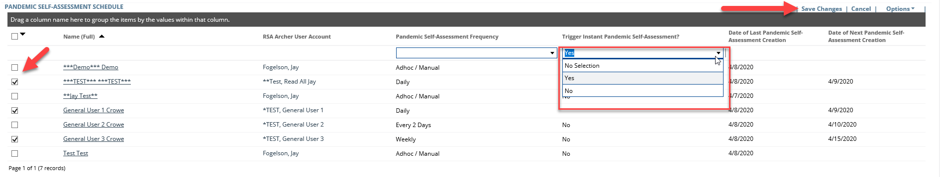

### Support actions

#### Task 1: Create and submit a support action

1. Click Add New to create a Support Action from an existing Pandemic Case record.
2. Complete the applicable fields.
3. Go to the Submission section at the bottom of the record. Change the Submission Decision field to Ready to Submit.
   * Ready to Submit: This selection moves the record to the next workflow stage.
   * Draft: This selection allows the user to save the record and return later.
4. Click Submit Support Request under the Actions menu at the top of the record.

#### Task 2: Review a support action

1. Go to the applicable record using one of the methods identified in the Navigation section.
2. Go to the Review section of the record and complete the Reviewer Decision field.
   * Approve: This selection allows the user to move the Support Action to the next workflow stage.
   * Return: This selection allows the user to return to the Submitter for resubmission.
   * Cancel/Reject: This selection allows the user to end the workflow and cancel the record.
   * Decision Pending: This selection allows the user to save and return to the record later.
3. Click Submit Review under the Actions menu at the top of the record.

#### Task 3: Complete delivery

1. Go to the applicable record using one of the methods identified in the Navigation section.
2. Complete applicable information.
3. G to the Delivery section at the bottom of the record and complete the Delivery Decision.
   * Delivered: This selection allows the user to move the record to the next workflow stage.
   * Return for Review: This selection allows the user to return to the Submitter for resubmission.
   * Decision Pending: This selection allows the user to save the record and return later.
4. Click Submit Delivery Decision under the Actions menu at the top of the record.

#### Task 4: Complete recovery

**Note:** This workflow stage will only be performed if the Recoverable field on the Support Action was marked Yes or Unknown.

1. Go to the applicable record using one of the methods identified in the Navigation section.
2. Complete applicable information.
3. Go to the Recovery section at the bottom of the record and complete the Recovery Status.
   * Complete: This selection moves the record to the next workflow stage.
   * In Progress: This selection allows the user to save the record and return later.
   * Not Started: This selection allows the user to save the record and return later.
4. Click Mark Recovery Complete under the Actions menu at the top of the record.

### Exposure actions

#### Task 1: Create and submit an exposure action

1. Click Add New to create an Exposure Action from an existing Pandemic Case record.
2. Complete the applicable fields.

* **Note:** The Action Type field dynamically changes the record to require applicable information.

1. Go to the Submission section at the bottom of the record and complete the Submission Decision field.
   * Action Complete – Send for Review: This selection moves the record to the next workflow stage.
   * In Process -This selection allows the user to save and return later.
2. Click Submit for Review under the Actions menu at the top of the record.

#### Task 2: Review an exposure action

1. Go to the applicable record using one of the methods identified in the Navigation section.
2. Go to the Review section of the record. Complete the Reviewer Decision field.
   * Approve: This selection allows the user to move the Support Action to the next workflow stage.
   * Return: This selection allows the user to return to the Submitter for resubmission.
   * Decision Pending: This selection allows the user to save and return to the record later.
3. Click Submit Review under the Actions menu at the top of the record.

### Essential personnel authorization

#### Task 1: Create and submit an essential personnel authorization

1. Create an Essential Personnel Authorization using one of the methods identified in the Navigation section.
2. Associate to the applicable Facilities record, by utilizing the ellipses lookup function. Click Apply.
3. Complete the applicable information.
4. Associate the applicable Contact record by utilizing the Lookup function.

* **Note:** The applicable personnel field will dynamically change based on response to the “Reason(s) for On-Site Personnel” field.

1. Go to the Submission section at the bottom of the record. Complete the Submission section.
   * Ready to Submit: This selection moves the record to the next workflow stage.
   * Draft: This selection allows the user to save the record and return later.
2. Click Submit for Review under the Actions menu at the top of the record.

#### Task 2: Perform primary review of essential personnel authorization

1. Go to the applicable record using one of the methods identified in the Navigation section.
2. Go to the Primary Approval section at the bottom of the record. Complete the Primary Reviewer Decision field.
   * Approve: This selection moves the record to the next workflow stage.
   * Deny: This selection ends the workflow.
   * Return for Additional Information: This selection returns the record to the Submitter for resubmission.
   * Decision Pending: This selection allows the user to save the record and return later.

* **Note:** If only some of the contacts listed should be approved, the Primary Reviewer canmake updates to the record by removing contacts, or select Return for Additional Information with notes for the Submitter to make changes and resubmit.

1. Click Submit Primary Review under the Actions menu at the top of the record.

#### Task 3: Perform secondary review of essential personnel authorization

1. Go to the applicable record using one of the methods identified in the Navigation section.
2. Go to the Secondary Approval section at the bottom of the record. Complete the Primary Reviewer Decision field.
   * Approve: This selection moves the record to the next workflow stage.
   * Deny: This selection ends the workflow.
   * Return for Additional Information: This selection returns the record to the Submitter for resubmission.
   * Decision Pending: This selection allows the user to save the record and return later.

**Note:** If only some of the contacts listed should be approved, the Secondary Reviewer should select Return for Additional Information with comments for updates to be resubmitted. If all contacts listed are rejected, the Secondary Reviewer should select Deny to close the request.

1. Click Submit Secondary Review under the Actions menu at the top of the record.

## Appendix A

Screenshots of calculated cross-reference configuration for the Contacts application.

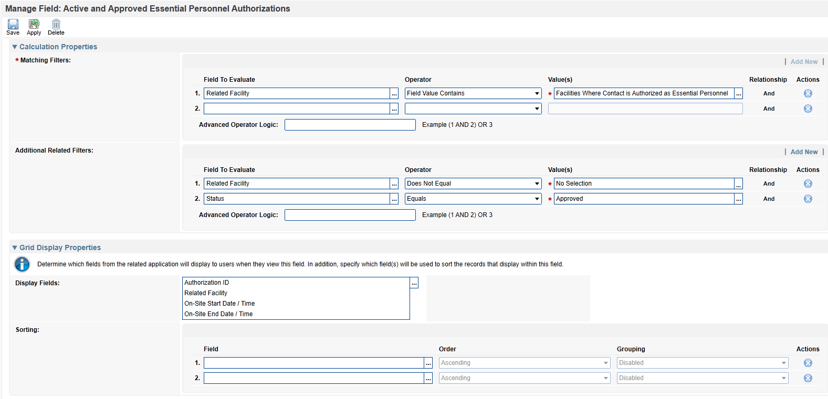

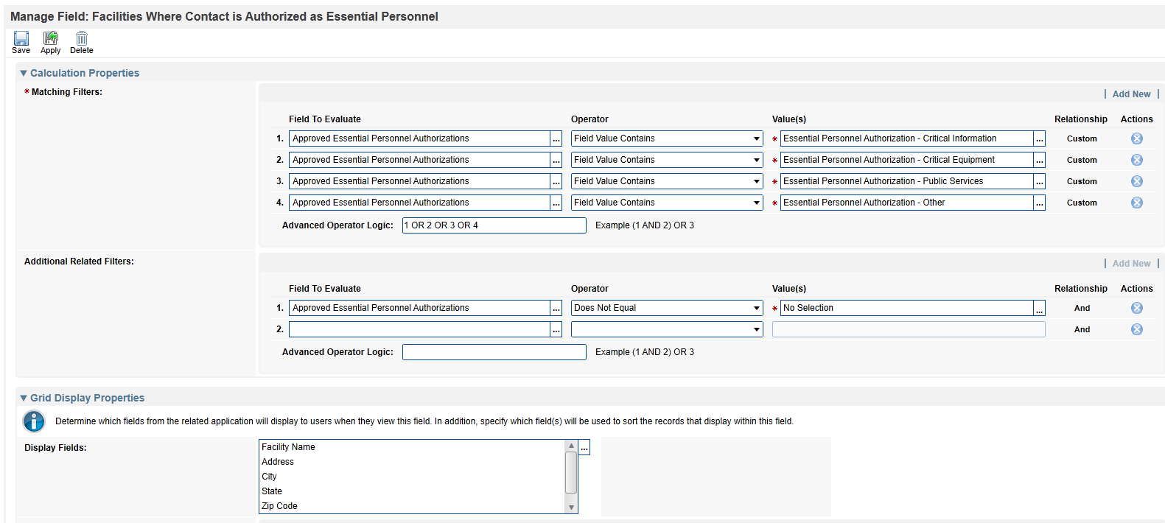

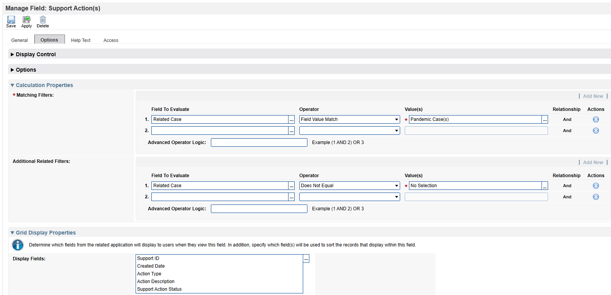

## Appendix B

Screenshots of calculated cross-reference configuration for the Facilities application.

